EXERCISE 4 - parallel for vs parallel for collapse(2)
Files : exercise04.c (original code)
exercise04_collapse.c (with collapse(2))
Compile / run
gcc -fopenmp exercise04.c -o exercise04
OMP_NUM_THREADS=4 ./exercise04
gcc -fopenmp exercise04_collapse.c -o exercise04_collapse
OMP_NUM_THREADS=4 ./exercise04_collapse

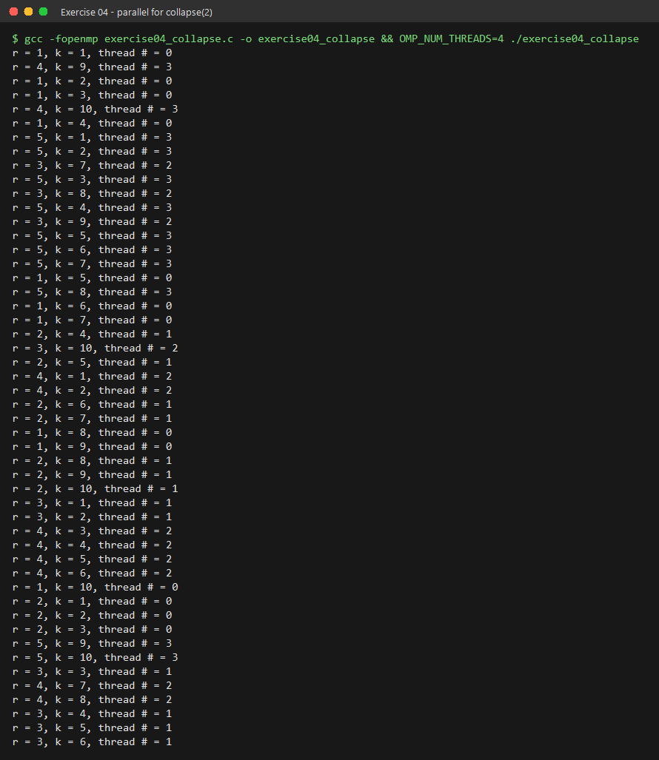
1. #pragma omp parallel for
---------------------------
Only the OUTER loop (r = 1..5) is parallelised. The 5 iterations of r are
split between the 4 threads; each thread then runs the WHOLE inner loop
(k = 1..10) for its own r values.

thread r values iterations
------ ----------- ----------
0 r = 1, r = 2 20
1 r = 3 10
2 r = 4 10
3 r = 5 10

5 does not divide by 4, so the work is UNBALANCED - thread 0 does twice
as much as the others.

2. #pragma omp parallel for collapse(2)
---------------------------------------
collapse(2) merges the two loops into ONE iteration space of 5 x 10 = 50
(r,k) pairs and distributes those between the threads.

thread (r,k) pairs iterations
------ ------------------ ----------
0 (1,1) ... (2,3) 13
1 (2,4) ... (3,6) 13
2 (3,7) ... (4,8) 12
3 (4,9) ... (5,10) 12

The split no longer follows the r boundaries (thread 0 and 1 share
r = 2), and the load is now BALANCED (13/13/12/12).
